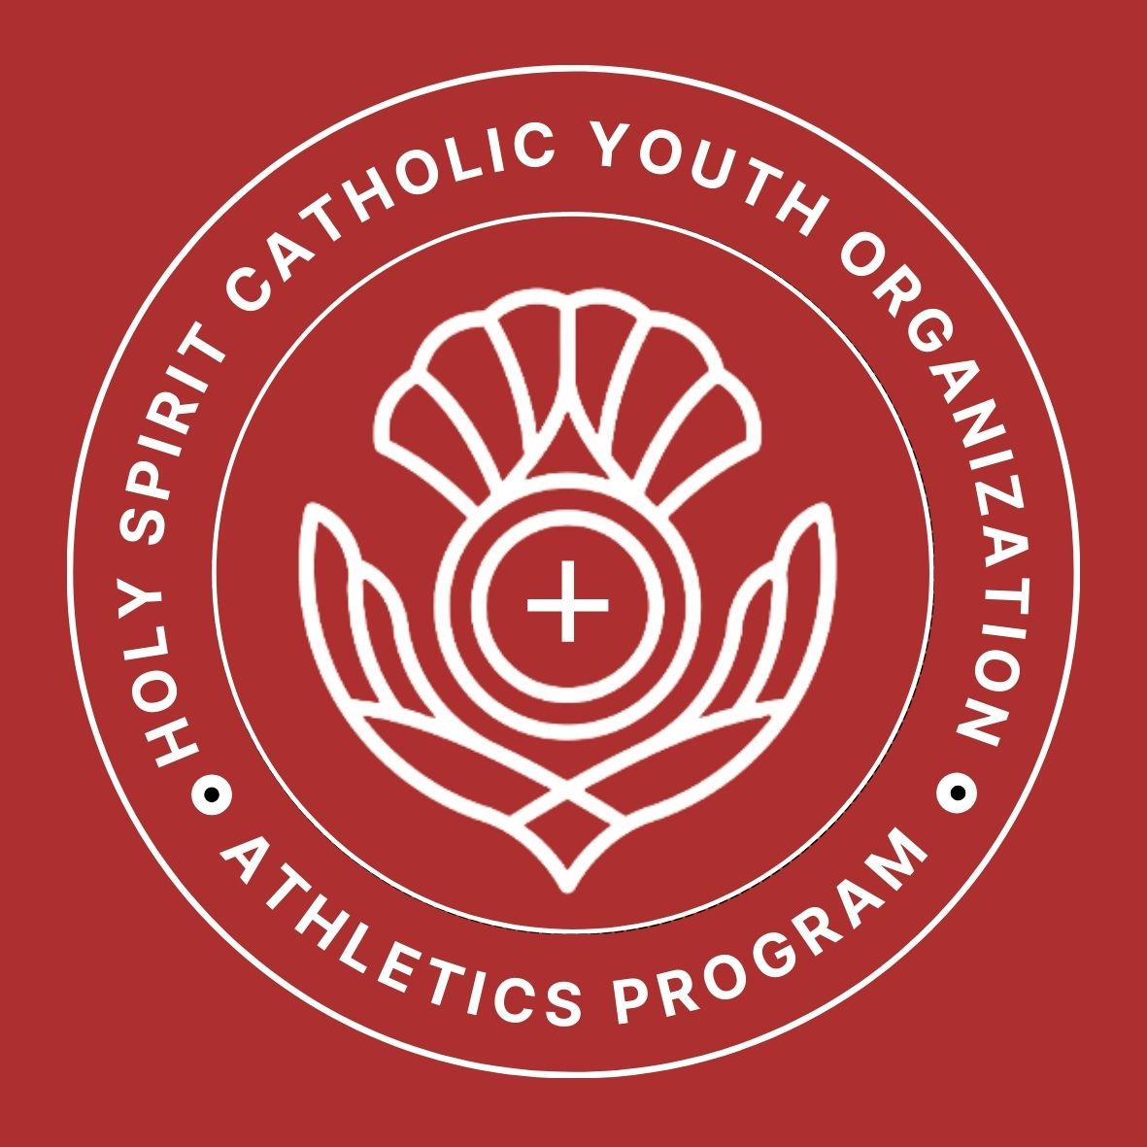
Holy Spirit CYO
SCHOLARSHIP PROGRAM
Catholic Youth Organization, Oakland Diocese

The Holy Spirit Catholic Youth Organization (HSCYO) Athletic Program will be awarding scholarships to two (2) student athletes. Each Scholarship will be worth $500. An application may be downloaded from the HSCYO website, holyspiritcyo.com. A $500 scholarship will be awarded to one male and one female 8th grade graduating student athlete. Eligibility is based on the HSCYO Guidelines which are explained below. The deadline for submitting your postmarked application is
Friday, 22 May 2026.

Thank you,
Holy Spirit CYO Board of Directors

Holy Spirit CYO Scholarship Program – Eligibility Guidelines

PURPOSE:
The purpose of the HSCYO Scholarship is to recognize athletic achievement, promote leadership, good sportsmanship, encourage high school achievement among all athletes, and to assist with the cost of high school education. A $500 scholarship will be awarded to one male student athlete and one female student athlete annually. In the event of a tie, the scholarship will be divided equally among the recipients.
ELIGIBILITY:
Any graduating 8th grade student who has participated in Holy Spirit CYO for at least three full seasons (at least one of which must have been during that student’s 8th grade year) will be eligible for this scholarship. The applicant shall have been accepted (or have made application and is pending) to a recognized Catholic High School.

ELIGIBILITY CRITERIA:
Athletic Participation: Applicant must be an 8th grade student in good standing with Holy Spirit CYO and who has participated as an athlete in at least one sports program with HSCYO for a minimum of three full seasons. The applicant’s record will be verified by the Athletic Directors and the HSCYO Board of Directors Selection Committee after submission of the application.

Good Sportsmanship: Applicant must exemplify good sportsmanship, including attitude toward team members, coaches, equipment, officials, and spectators.
Financial Need: Financial need is not a consideration.

References: List three (3) references that can verify his/her CYO participation. Only one reference can be a relative.

Participation and Achievement form: 6th - 8th Grade Athletic Participation and Achievement form must be completed and submitted with application.

Essay: Students are required to type an essay using the topic:

In what ways have CYO sports helped you practice your faith?
- Essay must be 500 words or less
- Essay must be prepared in a Word document with 1” margins.
- Times or Cambria 12-point font.
- Include a title page for your essay with the following information:
    - Title Page
    - Include your name
- Number each page. Use a header that includes the title of your essay and your name on each page.
Application Form: Student must complete and submit the application on the prescribed form, include the 500-words or less typed essay, and the Participation and Achievement form. Entries must be postmarked on or before Friday, 22 May 2026 and mailed to:
Holy Spirit CYO
Scholarship Program
37588 Fremont Blvd.
Fremont, CA 94536

Application Requirements
Once the “eligible” applicant has received the Holy Spirit CYO Scholarship Application, he/she must complete the application process as listed. The Scholarship Selection Committee will be contacting the 8th grade coach for their evaluation.
Payment of Scholarship
A one-time payment will be made to the registrar of the recipient’s high school at the beginning of the school year and only after verification of enrollment by the high school.
Selection Committee
Holy Spirit CYO Board members will serve as the “Selection Committee.” Coaches or faculty members of HSCYO and Holy Spirit School may be consulted for information regarding individual applicants; they will NOT, however, have any vote in the selection process. HSCYO Board members who are a parent, step-parent, guardian, of a graduating student-athlete may NOT participate on the Scholarship Selection Committee, and a replacement may be appointed.
Deadline
Application must be postmarked on or before Friday, 22 May 2026. Applications submitted after this date will not be considered.

Holy Spirit CYO
Catholic Youth Organization (CYO), Oakland Diocese
SCHOLARSHIP PROGRAM APPLICATION

Student’s Name: ________________________________________Phone: (H) _________________ (C) ____________________

Student’s Email Address: _____________________________________________________________________________________

Parent/Guardian Name: _______________________________Phone: (H) _________________ (C) ____________________

Parent/Guardian Email Address: ____________________________________________________________________________

References:

Name: _______________________________________________ Contact information: __________________________________

Name: _______________________________________________ Contact Information: __________________________________

Name: _______________________________________________ Contact Information: __________________________________

School Information

Current School attending: ____________________________________________________________________________________

Catholic High School you plan to attend: ____________________________________________________________________

School Address: _______________________________________________________________________________________________

Have you been accepted? ________________ If not, please explain: __________________________________________

__________________________________________________________________________________________________________________

Holy Spirit CYO Scholarship Program - Eligibility Guidelines

PURPOSE:
The purpose of the HSCYO Scholarship is to recognize athletic achievement, promote leadership, good sportsmanship, encourage high school achievement among all athletes, and to assist with the cost of high school education. A $500 scholarship will be awarded to one male student athlete and one female student athlete annually. In the event of a tie, the scholarship will be divided equally among the recipients.
ELIGIBILITY:
Any graduating 8th grade student who has participated in Holy Spirit CYO for at least three full seasons (at least one of which must have been during that student’s 8th grade year) will be eligible for this scholarship. The applicant shall have been accepted (or have made application and is pending) to a recognized Catholic High School.

ELIGIBILITY CRITERIA:
Athletic Participation: Applicant must be an 8th grade student in good standing with Holy Spirit CYO and who has participated as an athlete in at least one sports program with HSCYO for a minimum of three full seasons. The applicant’s record will be verified by the Athletic Directors and the HSCYO Board of Directors Selection Committee after submission of the application.

Good Sportsmanship: Applicant must exemplify good sportsmanship, including attitude toward team members, coaches, equipment, officials, and spectators.
Financial Need: Financial need is not a consideration.
References: List three (3) references that can verify his/her CYO participation. Only one reference can be a relative.

Participation and Achievement form: 6th - 8th Grade Athletic Participation and Achievement form must be completed and submitted with application.

Essay: Students are required to type an essay using the topic:

In what ways have CYO sports helped you practice your faith?
- Essay must be 500 words or less
- Essay must be prepared in a Word document with 1” margins.
- Times or Cambria 12-point font.
- Include a title page for your essay with the following information:
    - Title Page
    - Include your name
- Number each page. Use a header that includes the title of your essay and your name on each page.

Application Form: Student must complete and submit the application on the prescribed form, include the 500-words or less typed essay, and the Participation and Achievement form. Entries must be postmarked on or before Friday, 22 May 2026, and mailed to:
Holy Spirit CYO Athletics
Scholarship Program
37588 Fremont Blvd.
Fremont, CA 94536

Application Requirements
Once the “eligible” applicant has received the Holy Spirit CYO Scholarship Application, he/she must complete the application process as listed. The Scholarship Selection Committee will be contacting the 8th grade coach for their evaluation.

Parent/Guardian & Applicant Signatures

By signing below I certify that I understand the criteria for the scholarship and submission deadlines for the application and recommendation form.

I hereby authorize the review of all aspects of this application by the Holy Spirit CYO Scholarship Selection Committee for the sole purpose of consideration for this scholarship award. Furthermore, I acknowledge that the information provided herein is true and correct.

______________________________________________________________________________ __________________________________
Parent/Guardian Signature Date

___________________________________________________ __________________________ __________________________________
Applicant’s Signature Date

Please attach your essay and the 6th - 8th Grade
Athletic Participation/Achievements form with this application.

Must be postmarked by
Friday, 22 May 2026

6th - 8th GRADE ATHLETIC PARTICIPATION/ACHIEVEMENTS:
Describe below your athletic participation and achievements for each year at Holy Spirit CYO.

HSCYO 6th Grade

HSCYO 7th Grade

HSCYO 8th Grade

